Square Root Parent Function

Domain
Interval Notation____________________
Inequality Notation_________________ Set Notation_______________
Range
Interval Notation____________________
Inequality Notation_________________ Set Notation_______________
Other Features
Max/Min (As a point)__________
Type of Symmetry_______
Interval of increasing/decreasing
_____________________________

End Behavior__________________
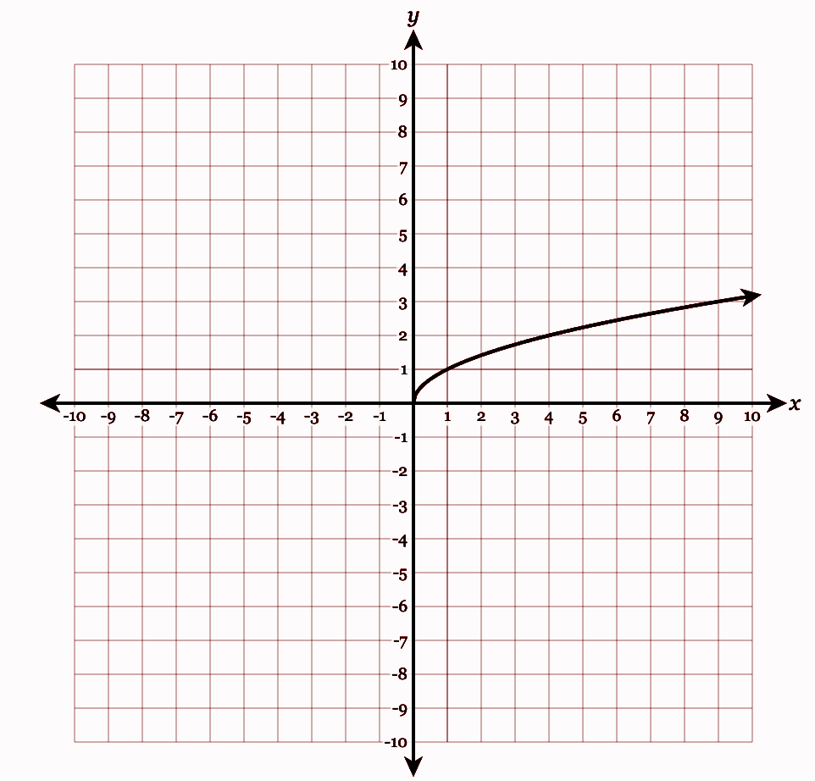

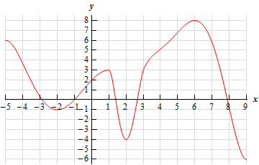

Absolute Value parent Function

Domain
Interval Notation____________________
Inequality Notation_________________ Set Notation_______________
Range
Interval Notation____________________
Inequality Notation_________________ Set Notation_______________
Other Features
Max/Min (As a point)__________
Type of Symmetry_______
Interval of increasing/decreasing
_____________________________

End Behavior__________________
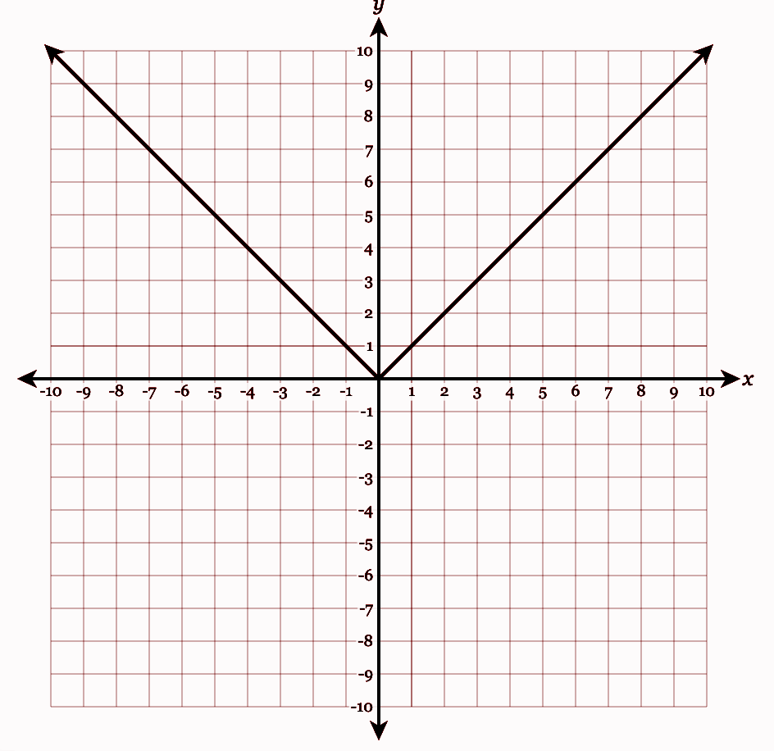
DoDomain_____

For the Function to the left,
What is the local maximum on the interval [-4,0]?______
What is the global maximum?_________
What is the local maximum on the interval [-1,2]?_____
What is the global minimum?________
What is the local minimum on the interval [-3,3]?_____
What are the x- intercepts?______________
What is the y-intercept?_______________
Can a function have more than one y-intercept?_____
Why or why not?______________________________________

Linear Parent Function

Domain
Interval Notation____________________
Inequality Notation_________________ Set Notation_______________
Range
Interval Notation____________________
Inequality Notation_________________ Set Notation_______________
Other Features
Max/Min (As a point)__________
Type of Symmetry_______
Interval of increasing/decreasing
_____________________________

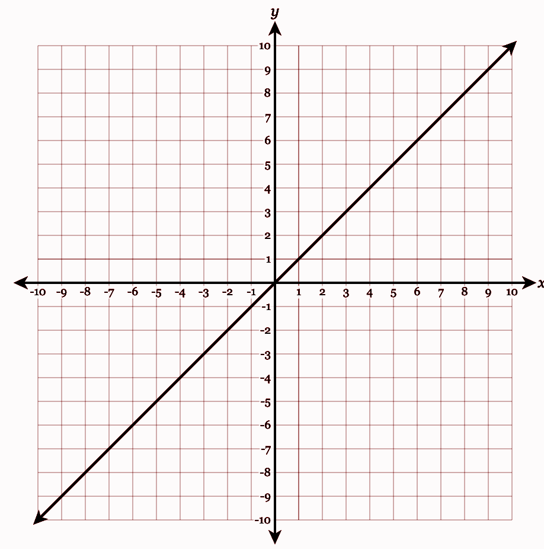
End Behavior__________________

List the functions that have the same domain._____________________
___________________________

List the Functions that have the same Range._____________________
___________________________

Which functions have a minimum?______________________
Is the minimum local or global?________
Why?____________________________

Quadratic Parent Function

Domain
Interval Notation____________________
Inequality Notation_________________ Set Notation_______________
Range
Interval Notation____________________
Inequality Notation_________________ Set Notation_______________
Other Features
Max/Min (As a point)__________
Type of Symmetry_______
Interval of increasing/decreasing
_____________________________

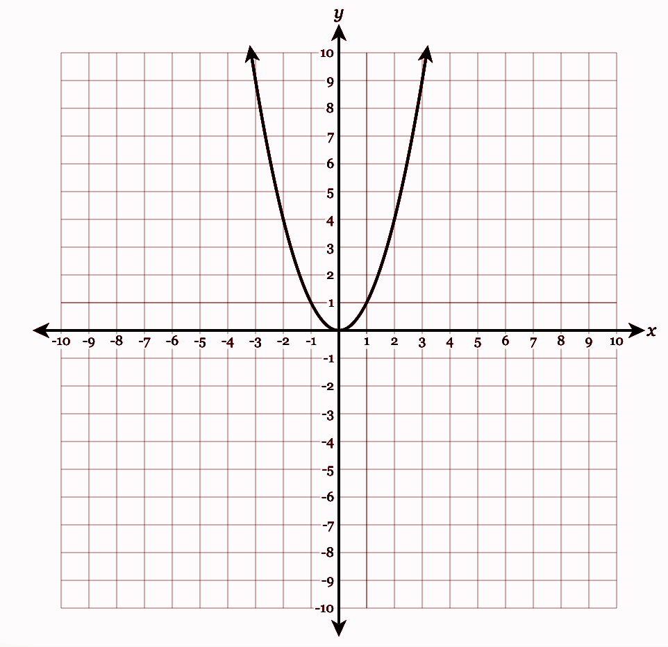
End Behavior__________________

End

Use the table below to answer the question.
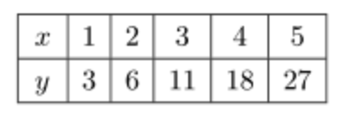

Which of the following describes the relationship between $x$ and $y$?
- $y=3x$ b. $y=5x-2$
c. $y=x^{2}+2$ d. $y=x^{2}$
Do you think this is discrete or continuous? _____
Why?____________________________________

